**A minimum problem**

Find the shortest distance from the origin O to the curve $y=\frac{1}{x^{4}}$ (where x > 0).

Use the following methods:

**(1) Calculus,**

**(2) A.M.≥ G.M.**

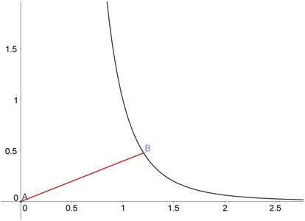



**(1) Calculus:**

**Method 1**

$s=AB=\sqrt{{\left(x-0\right)}^{2}+{\left(y-0\right)}^{2}}=\sqrt{x^{2}+y^{2}}=\sqrt{x^{2}+{\left(\frac{1}{x^{4}}\right)}^{2}}=\sqrt{x^{2}+\frac{1}{x^{8}}}$

${s^{2}=x}^{2}+\frac{1}{x^{8}}$

$2s\frac{ds}{dx}=2x-\frac{8}{x^{9}}⇒\frac{ds}{dx}=\frac{1}{s}\left(\frac{x^{10}-4}{x^{9}}\right)$

For critical points, $\frac{ds}{dx}=0$.

$x^{10}-4=0⟹ x=\sqrt[10]{4}=\sqrt[5]{2}≈1.148698354997$

For $0<x<\sqrt[5]{2}, \frac{ds}{dx}<0$. and for $x>\sqrt[5]{2}, \frac{ds}{dx}<0$.

Therefore y is a minimum when $x=\sqrt[5]{2}$.

When $x=\sqrt[5]{2},$

$s=\sqrt{{\left(\sqrt[5]{2}\right)}^{2}+\frac{1}{{\left(\sqrt[5]{2}\right)}^{8}}}=\sqrt{\frac{{\left(\sqrt[5]{2}\right)}^{10}+1}{{\left(\sqrt[5]{2}\right)}^{8}}}=\sqrt{\frac{4+1}{\sqrt[5]{256}}}=\sqrt{\frac{5}{\sqrt[5]{256}}}=\sqrt[10]{\frac{3125}{256}}≈1.2842838037078$

**Method 2**

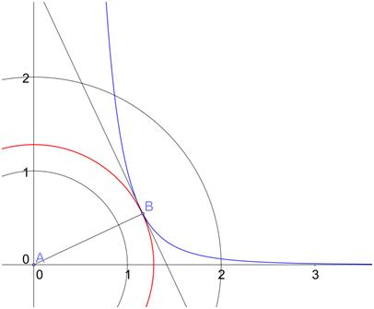 Construct a circle centre origin and radius r : $x^{2}+y^{2}=r^{2}$…. (1)

Common tangent

Too big circle, two intersection points

Too small circle, no intersection point

In order to find the shortest r, we like to have this circle **touches** the given curve:

$y=\frac{1}{x^{4}}$…. (2)

Then (1) and (2) should have a common tangent

at the point of contact .

Differentiate (1) and (2),

$$\left\{\begin{aligned} 2x+2y\frac{dy}{dx}=0 ⟹ \frac{dy}{dx}=-\frac{x}{y} \\ \frac{dy}{dx}=-\frac{4}{x^{5}}\end{aligned}\right.$$

$∴ -\frac{x}{y}=-\frac{4}{x^{5}} ⟹ y=\frac{x^{6}}{4}$…. (3)

By (2), $\frac{1}{x^{4}}=\frac{x^{6}}{4} ⟹ x^{10}=4 ⟹ x=\sqrt[10]{4}=\sqrt[5]{2}≈1.148698354997$

By (3), $y=\frac{{\left(\sqrt[5]{2}\right)}^{6}}{4}$

By (1), ${r^{2}=x}^{2}+y^{2}={\left(\sqrt[5]{2}\right)}^{2}+{\left[\frac{{\left(\sqrt[5]{2}\right)}^{6}}{4}\right]}^{2}≈1.6493848884661$

$r≈1.2842838037078$

**(2) A.M.≥ G.M. :**

$s=AB=\sqrt{{\left(x-0\right)}^{2}+{\left(y-0\right)}^{2}}=\sqrt{x^{2}+y^{2}}=\sqrt{x^{2}+{\left(\frac{1}{x^{4}}\right)}^{2}}=\sqrt{x^{2}+\frac{1}{x^{8}}}$

$=\sqrt{\frac{x^{2}}{4}+\frac{x^{2}}{4}+\frac{x^{2}}{4}+\frac{x^{2}}{4}+\frac{1}{x^{8}}}≤\sqrt{5\sqrt[5]{\left(\frac{x^{2}}{4}\right)\left(\frac{x^{2}}{4}\right)\left(\frac{x^{2}}{4}\right)\left(\frac{x^{2}}{4}\right)\left(\frac{1}{x^{8}}\right)}}$ (A.M. ≥ G.M.)

$=\sqrt{5 \sqrt[5]{\frac{1}{256}}}=\sqrt[10]{\frac{3125}{256}}≈1.2842838037078$

The point is to get rid of all x !

where equality holds if and only if

$\frac{x^{2}}{4}=\frac{1}{x^{8}} ⇔ x^{10}=4 ⇔ x=\sqrt[10]{4}=\sqrt[5]{2}≈1.148698354997$

**Yue Kwok Choy**

**12 June, 2015**